Tasks

1. Formatting CSAs (see below)
2. Competitor List Dropdown (see attached design doc – “Competitor List Dropdown”)
3. Competitor Codes (see attached design doc – “Competitor List Dropdown – Duplicate Competitor Codes”)

CSAs

Steps for Scenario 1

1. Doc Engine
   1. CSA (CSA_bmDocEdClone_2

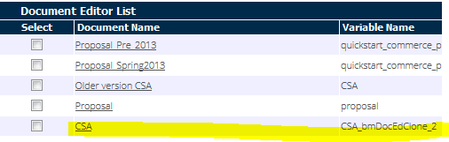

* 1. Pages:
     1. CSAItems (for the front TCs)
     2. CSARearItems (for the rear TCs)

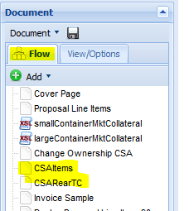

1. Double click on the pencil next to FrontTAndC or RearTAndC (depending on page)

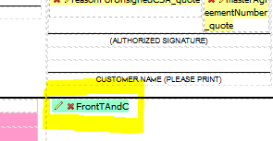

1. Click on the pencil for the applicable Front TC
2. Highlight the text and change it to Arial Unicode, size 8.
   1. Text is located in complex conditionals (FrontTAndC and RearTAndC)

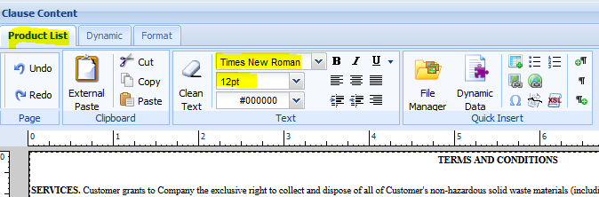

1. Remove all line spacing and then add it back in.
2. Did this for all 25 TCs. Note, TC 6, 14, and 20 require special attention to spacing.
3. Save clause

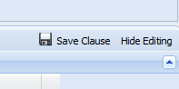

1. Save conditional

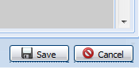

1. Save page

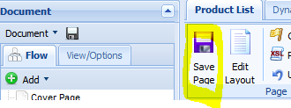

1. Save document

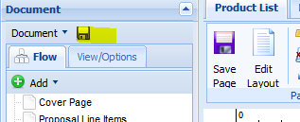

1. Deploy document

Steps for Scenario 2 (If 8 Unicode is not small enough)

1. Takes steps 1-3 from Scenario 1
2. Inspect element with Firebug (ex. TC 6)
3. Set font to size 7, 6, or 5
4. Redo spacing
5. Save and deploy all changes

Unit Test

1. Open any quote where you can print documents (ex. A147326)
2. Expand the System Information section
3. Enter the numbers for the TCs that you want to test in the Front TC Content and Rear TC Content fields.
4. Click “Print all CSAs.”
5. Confirm that the front and rear TCs print on 2 pages combined.